**CPRS/VistA Pattern Library**

Veterans Health Administration

Date Created: 3/27/19

Created by: Kas Adams & Kendra Tibbs

**Table of Contents**

**Introduction** 3

**Purpose** 3

**Scope** 3

**Glossary of Terms** 4

**Architecture Overview Infographic** 7

**Best Practices** 8

**Quick Reference for Design Components in CPRS/VistA** 9

**Design Components** 10

**Prompts** 10

Pros 10

Cons 10

**Groups** 11

Pros 11

Cons 11

**Template Fields** 12

Pros 12

**Case Study** 17

# **Introduction**

The Office of Human Factors Engineering was charged with creating a design library for the Computerized Patient Record System (CPRS)/ Veterans Health Information Systems and Technology Architecture (VistA)  to be used as an efficient means of communication among project team members with diverse backgrounds. Provision of this tool proposes to significantly shorten development time and reduce re-work by project teams and Health Informatics Specialists/Clinical Applications Coordinators (HIS/CAC).

## **Purpose**

The purpose of this document is to provide a high level, visual reference artifact for product teams creating CPRS/VistA tools. All members should be able to review product designs and understand tool capabilities. It can provide an overview of functions and features.

## **Scope**

This document only describes some components of CPRS/VistA. This document does not provide a narrative account of the requirements development process, the software design lifecycle, or usability testing. Finally, this document does not discuss application of the components to mapping data elements, workflow designs or process re-engineering.

# **Glossary of Terms**

**Alternate progress note text**

Output of the template that is different than the template text.

**Branching logic**

A reminder definition string used to determine a true or false statement.  A reminder group in any reminder dialog (template or clinical reminder) can be suppressed based on the results of the reminder definition.  For example, if a health factor is present that the patient has already been screened for item X, that dialog group can be suppressed if HF (X) = true.  I.e. the user will not be prompted to repeat the screen.

**Clinical Reminder Dialog (CRD)**

A CPRS tool that accepts user input focused on a task. This data populates in a TIU note. It can associate the tasks with Health Factors, standardized ICD and CPT codes for tracking, analysis and reporting.

**Computerized Patient Record System (CPRS )**

The graphic user interface for the VA’s electronic health record. It is the clinical front end to the VistA database

**Components**

The module that is presented in any given template. Typically, components include groups, elements, and health factors.

**CPT**

Current Procedural Terminology. Medical code set used for reporting medical, surgical and diagnostic procedures and services to entities’ such as physicians, health insurance companies, and accreditation organizations.

**Dialog element**

Elements are the most granular component of a reminder dialog. They are defined primarily to represent sentences to display in the CPRS window with a check-box. They can print text, render input fields, or pull data from findings tables.

**Dialog group**

A reminder component that groups dialog elements or other groups. Elements and groups nested within parent groups inherent functions of the parent group and typically share behavioral and thematic characteristics. A group can be defined with a finding item and a check-box. The components in the group can be hidden from the CPRS GUI until the dialog group is selected.

**Finding item**

A piece of information that can be searched by the reminder.

**Health factor**

A computerized component that captures patient information for which no standard national code exists, such as Family History of Alcohol Abuse, Lifetime Non-Smoker, etc.

**ICD**

International Classification of Diseases. A system used by physicians and other healthcare providers to classify and code all diagnoses, symptoms and procedures recorded in conjunction with hospital care in the United States.

**Laboratory test**

Only individual tests may be selected as a reminder finding; lab panels cannot be used.

**Local reminders**

Reminders developed or distributed by VA facilities.

**National reminders**

Reminders developed and distributed by VA Central Office. Reminder terms are predefined finding item(s) associated with national reminders that can be used to map local findings to national findings, thus providing a method to standardize these findings for national use.

**Patient Data Object (PDO)**

A shared CPRS template component that may be inserted into a users’ template. A user may create a personal template by combining text, Template Fields, and Patient Data Objects.

**Prompts**

A reminder component programmed in VistA and selectable from inside CPRS. Specific multiple choice answer to a question. Can be connected to a health factor.

**PXRM**

The clinical reminder package namespace.

**Reminder definition**

The internal logic of the reminder. It describes the patients the reminder applies to, how often it is given, and what resolves or satisfies the reminder. It is comprised of the predefined set of finding items used to identify patient cohorts and reminder resolutions.

**Reminder dialog**

Reminder Dialogs are used in CPRS to allow clinicians to select actions that satisfy or resolve reminders for a patient. Information entered through reminder dialogs update progress notes, place orders, and update other data in the patient’s medical record. A reminder dialog is created by the assembly of elements and groups into an orderly display, which is seen by the user in the CPRS GUI.

**Reminders exchange**

The Clinical Reminders Exchange Utility provides a mechanism for sharing reminder definitions and dialog among sites throughout the VA or among sites within a VISN. Exchanging reminders helps to simplify reminder and dialog creation. It also helps to promote standardization of reminders based upon local, VISN, and national guidelines.

**Reminder finding**

Findings are types of data elements in VistA that determine a reminder’s status. Each finding is evaluated when a reminder is evaluated for a patient. Findings are either True (1) or False (0). Findings have three functions in reminder definitions: 1) to select the applicable patient population (Patient Cohort Logic); 2) to resolve the reminder (Resolution Logic); 3) to provide information.

**Reminder resolution**

A reminder is considered RESOLVED if the conditions defined by the reminder resolution logic have been met.

**Template Fields**

A reminder component selectable from inside CPRS that collects information from the user. It is always saved as free text. It cannot be connected to a health factor.

**Text Integrated Utility (TIU) Note**

A TIU note is the electronic note written by clinicians in CPRS. The TIU note is considered complete when the provider electronically signs it. An addendum may be applied to a completed note. TIU notes may be based on templates for modular customization, such as adding in a patient data object (PDO). Though not trackable, they have more functionality.

**VistA**

Veterans Health information Systems and Technology Architecture: The database/ core of the VA’s electronic health record. VistA uses a command line interface.

# **Architecture Overview Infographic**

The diagram is a graphic representation of general clinical reminder architecture and the information flow lifecycle. Briefly, end-users interact with reminder dialogs (i.e., graphic user interface representations of the reminder components) to review information in the database, enter data, and populate health factors, ICD and CPT codes that are then stored in a reminder findings table. Each reminder dialog is comprised of reminder elements and/or groups. The groups organize content into related themes with shared functional characteristics.

Selected elements and groups are associated with health factors. These factors essentially “tag” the data with a unique identifier. The information is then stored at a PXRM namespace or “address” in the reminder findings table.

The reminder summary extract can be used to generate reports from health factors, ICD and CPT codes stored in the findings table. Alternatively, sites can retrieve data from regional and national databases that archive VistA data (e.g., Regional Data Warehouse, Corporate Data Warehouse)

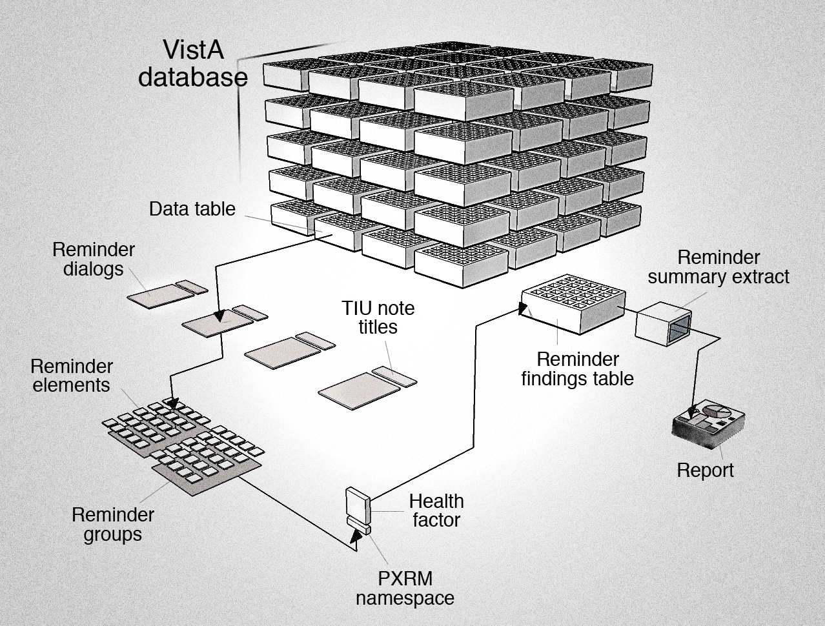

Graphic courtesy of Blake Lesselroth ©

# **Best Practices**

Below is a core sample of CPRS/VistA programming best practices from the National Clinical Reminder Dialog Workgroup and the Office of Human Factors Engineering:

* Narrow scope to addresses only what is needed
* Identify data items that need to be trackable before beginning development
  + Default to national health factors, ICD and CPT codes as appropriate
* Build template in smallest components possible to facilitate modification, if needed
* Make template and note output easy to read
  + Keep the wording short and concise
  + Avoid abbreviations that have not been previously spelled out
  + Express the same thing the same way for consistency
  + Minimize clicking and scrolling
  + Indent all template fields at least two spaces
  + Add trailing spaces to single line template fields
* Keep “like things” together
* Use clear visual breaks between different content areas
  + Blank lines
  + **** , ____, +++++, -----, etc.
  + Box only larger reminder groups so as not to make the template look too busy
* Display previous data (i.e. labs, health factors) only if the user needs to see the info
  + Keep the user in one place to view pertinent information
  + Make a checkbox to show/hide data
* Use branching logic to algorithmically guide user
  + Only show them items that need to be displayed (e.g. A primary care dialog for a male patient would not contain a breast exam)
* Label fields in reminder dialogs so they are easy to identify in error messages
* Use alternate progress note text that reads well and meets documentation requirements

# **Quick Reference for Design Components in CPRS/VistA**

|  |  |  |  |  |  |
| --- | --- | --- | --- | --- | --- |
|  | | **Elements** | **Groups** | **Template Fields** | **Prompts** |
| Health Factors | |  |  |  |  |
| Template fields: Default text editable | |  |  |  |  |
| Template fields: Default text not editable | |  |  |  |  |
| Template fields: Additional text in text box | |  |  |  |  |
| Template fields: Check boxes | |  |  |  |  |
| Template fields: Radio buttons | |  |  |  |  |
| Template fields: Nesting/hidden items | |  |  |  |  |
| Note Output: in line | |  | ** |  |  |
| Note Output: separate lines | | * |  |  | *** |
| Note Output: Horizontal | |  |  |  |  |
| Template fields: Horizontal & vertical items | |  |  |  |  |
|  |  | | | | |
| Programmed in VistA | |  |  |  |  |
| Programmed in CPRS | |  |  |  |  |
| Known usability issues | |  |  |  |  |

* Not recommended, difficult to implement

**Standard text and no selections/nesting choices

***Requires additional programming

# **Design Components**

## **Prompts**

|  |  |  |  |
| --- | --- | --- | --- |
| Pros: - Allows default text and additional typed information  - Allows checkboxes to be horizontal or vertical in template  - Produces one line of text in note output | | Cons: - Selections do not allow health factors †  - Usability/safety risk**  - Cannot align checkboxes with textbox  - Limits text box to 245 characters  † Can have a HF attached to an element that also has a prompt | |
| **Condition** | **Template** | | **Note Output** |
| Blank |  | |  |
| Selections marked |  | |  |
| Default text | ** Checkbox for default text not marked** | |  |
| Default text  & selections marked | ** Default text deleted** | |  |

## **Groups**

|  |  |  |  |
| --- | --- | --- | --- |
| Pros: - Allows health factors and orders  - Allows options to be visible or hidden/nested  - Allows combination of radio buttons and checkboxes  - Allows organization with indents and boxes | | Cons: - Limits spacing design options  - May require extra click  - Produces two lines of text in note output  - Note output is only horizontal | |
| **Condition** | **Template** | | **Note Output** |
| Blank: Visible |  | |  |
| Blank: Hidden |  | |  |
| Blank: Unhidden |  | |  |
| Selections marked |  | |  |

## **Template Fields**

Pros: - Allows single line and default text Cons: - Does not allow health factors

- Allows radio button, checkbox, combo box, hyperlinks - Does not allow editing of default text

- Allows fields to be required - Usability/safety risks**

| **Item** | **Template** | **Note Output** |
| --- | --- | --- |
|  |  |  |
| Button |  |  |
| Check boxes |  |  |
| Combo box |  |  |
|  |  |  |
| Edit box |  |  |
| Radio buttons |  |  |
|  |  |  |
| Text box  (default text)  Word processing |  |  |
| Date |  |  |
| Date & Time |  |  |

## **Case Study 1**

|  |  |
| --- | --- |
| Issue: Template is organized as a wall of text. It is hard to identify laboratory information. | |
| **Before** | **After** |
| image001  **1**  **2** | image002 |
| **Considerations:**  1. Make section header for laboratory tests visually distinct (i.e., capitalization and **)  2. Chunk laboratory content (i.e., indent and box it) | |

|  |  |
| --- | --- |
| **Case Study 2:** It is hard to identify what action needs to be taken if the “Yes” option is selected. | |
| **Before** | **After** |
|  |  |

**Consideration:**

Chunk information using outline formatting, indenting, and spacing.